**HOME**

**User Experience Scenario**

Version 1.0

Developed by Dao Quoc Trung

**Revision History**

|  |  |  |  |
| --- | --- | --- | --- |
| Name | Date | Reason to change | Version |
| Trung | 03/06/2021 | Initialize document | 1.0 |
|  |  |  |  |

**Table of Contents**

**Revision History 2**

1. **Common 4**
   1. Font 4
   2. Unit 4
   3. Definition 4
2. **Home Screen 4**
   1. Screen Layout 5
   2. Status Bar 6
   3. Widget 7
   4. Application Menu 8
3. **Flow specification 8**
   1. Open/Close an app 9
   2. Widget Information Flow 9
   3. Application Scroll 10
   4. Application Re-order 10
4. **COMMON**
   1. Font
      * Arial
   2. Unit
      * Pixel
   3. Definition
      * Mouse

|  |  |
| --- | --- |
|  | Left Click |
|  | Right Click |
|  | Hover |
|  | Swipe |
|  | Scroll |

* + - Status

|  |  |
| --- | --- |
|  | Normal |
|  | Focus |

1. **HOME SCREEN**
   1. Screen Layout

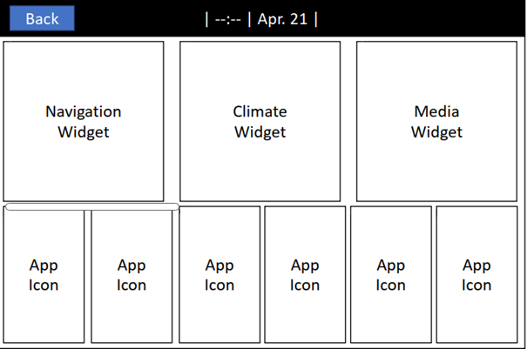

* 1. Status Bar

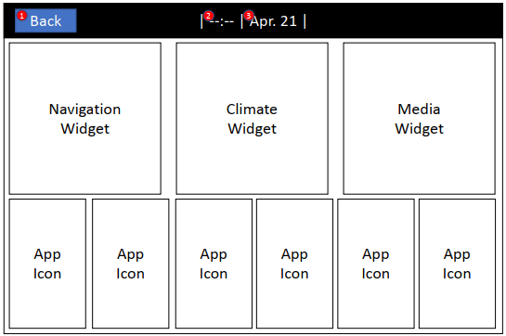

|  |  |  |  |  |
| --- | --- | --- | --- | --- |
| No. | Description | Type | Display Condition/Action Condition | Label |
| 1 | Back: Back to Home Screen | Button | Display it when enter other screen such as(Navigation, Climate, Media, …) | - |
| 2 | Time: Current Time | Text | Always | Format 24h (--:--) |
| 3 | Date: Current date | Text | Always | Format: <Short Month>. Day |

* 1. Widget

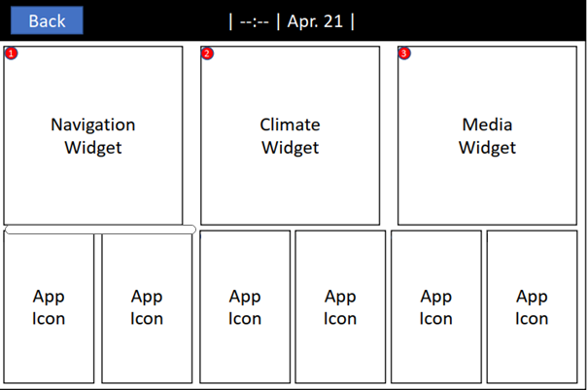

|  |  |  |  |  |
| --- | --- | --- | --- | --- |
| No. | Description | Type | Display Condition/Action Condition | Label |
| 1 | Navigation Widget: Go to navigation screen | Button | Always | - |
| 2 | Climate Widget: Go to climate screen | Button | Always | Climate |
| 3 | Media Widget: Go to Media Player screen | Button | Always | USB Music |

* 1. Application Menu

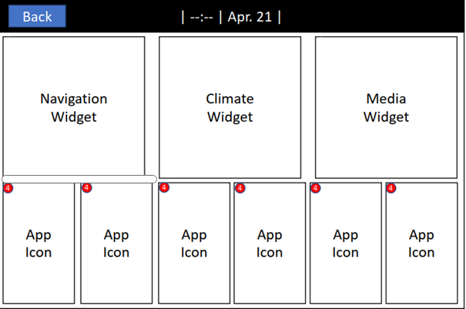

|  |  |  |  |  |
| --- | --- | --- | --- | --- |
| No. | Description | Type | Display Condition/Action Condition | Label |
| 4 | Application(Map , Video , Media, Phone, Radio, Setting) | Button | Always | Map. Video, Media Phone, Radio, Settings |

1. **FLOW SPECIFICATION**
   1. Open/Close an app

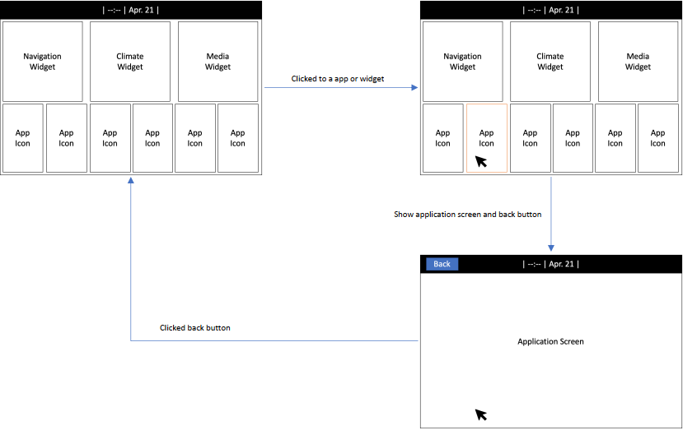

* 1. Widget Information Flow

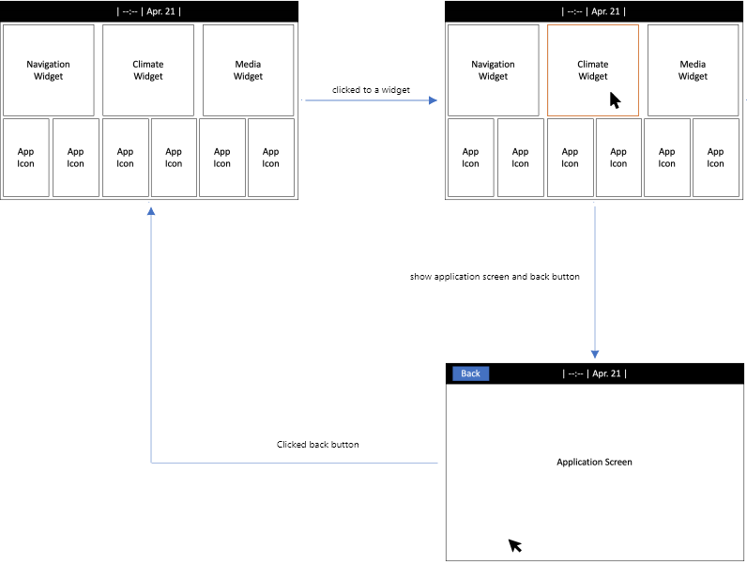

* 1. Application scroll

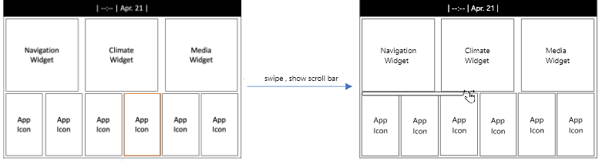

* 1. Application Re-order

